Project Report

Project Title :- Placement Management System using Node.js, Express.js, and MongoDB

2. Objective
The objective of this project is to develop a backend-based Placement Management System that manages students, departments, staff, and placement-related information. The system performs CRUD (Create, Read, Update, Delete) operations and demonstrates database relationships using MongoDB.

3. Technologies Used
Backend
- Node.js
- Express.js
Database
- MongoDB
- Mongoose ODM
API Testing
- Postman
Development Tools
- Visual Studio Code
- MongoDB Compass

4. Project Architecture
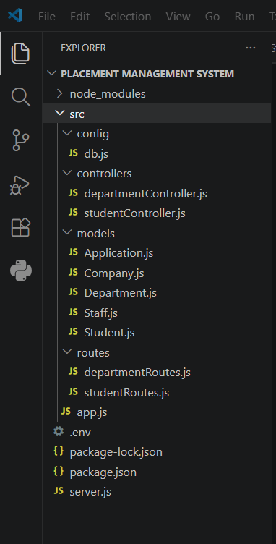

5. Database Design
Student Collection
Field | Type
name | String
email | String
phone | String
cgpa | Number
skills | Array
departmentId | ObjectId
Department Collection
Field | Type
name | String
students | Array of ObjectIds

6. Relationship Mapping
One-to-Many Relationship
A single department can have multiple students.
Department
|
|---- Student 1
|---- Student 2
|---- Student 3
MongoDB Implementation:
departmentId: {
type: mongoose.Schema.Types.ObjectId,
ref: "Department"
}
and
students: [{
type: mongoose.Schema.Types.ObjectId,
ref: "Student"
}]

7. Implemented CRUD Operations
Student Module
Create Student
POST
/api/students
Sample Request:
{
"name": "Aman Sharma",
"email": "aman@gmail.com",
"phone": "9876543210",
"cgpa": 8.5,
"skills": ["Java", "MongoDB"]
}
Get Students
GET
/api/students
Update Student
PUT
/api/students/:id
Delete Student
DELETE
/api/students/:id

Department Module
Create Department
POST
/api/departments
Get Departments
GET
/api/departments
Update Department
PUT
/api/departments/:id
Delete Department
DELETE
/api/departments/:id

8. API Testing
All APIs were tested using Postman.
The following operations were verified:
- Student Creation
- Student Retrieval
- Student Update
- Student Deletion
- Department Creation
- Department Retrieval
- Department Update
- Department Deletion

9. Screenshots Included
- Server Running Successfully
- Student GET API
- Student POST API
- Student UPDATE API
- Student DELETE API
- MongoDB Database Records
- Department POST API
- Department GET API

10. Advantages of the System
- Easy management of student information
- Efficient storage using MongoDB
- RESTful API architecture
- Scalable backend design
- Supports database relationships
- Easy integration with frontend applications

11. Future Enhancements
- Company Management Module
- Staff Management Module
- Placement Drive Management
- Student Authentication and Authorization
- Admin Dashboard
- Resume Upload System
- Interview Tracking
- Placement Statistics and Reports

12. Conclusion
The Placement Management System was successfully developed using Node.js, Express.js, and MongoDB. The project demonstrates CRUD operations, REST API development, MongoDB database connectivity, and relationship mapping between collections. The system provides a scalable foundation for managing placement-related activities in educational institutions.

